**Computer Networks Lab 8**

**Name: Vaibhav Chaudhari**

**ID: 2017B5A70834G**

**Use Wireshark to capture packets in your LAN.  
  
  
1. Show a round of execution of the DHCP protocol.**

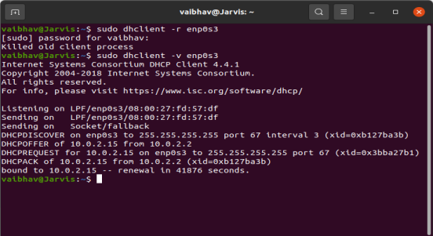

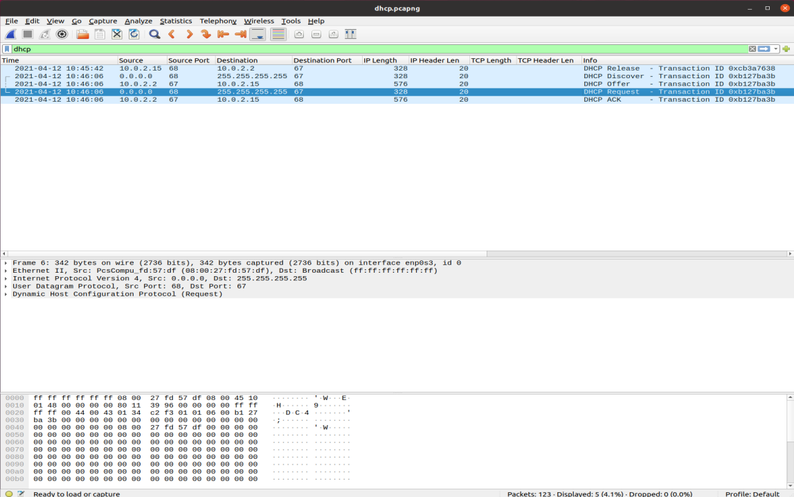

The filter used here is **dhcp** or **udp.port==67**. So we can use any one of them.

**Show DHCP Request (2 marks),**

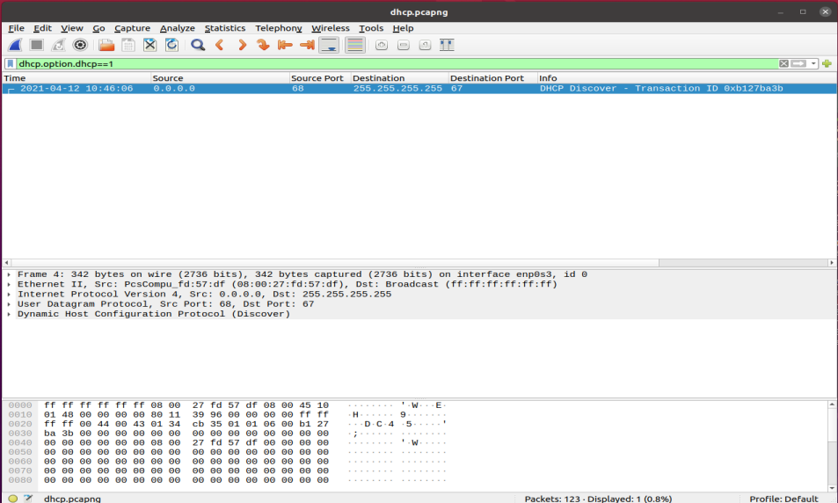

The filter is **dhcp.option.dhcp==1**

Here 1 is for Discover.

Here Discover=Request

**Reply (2 marks),**

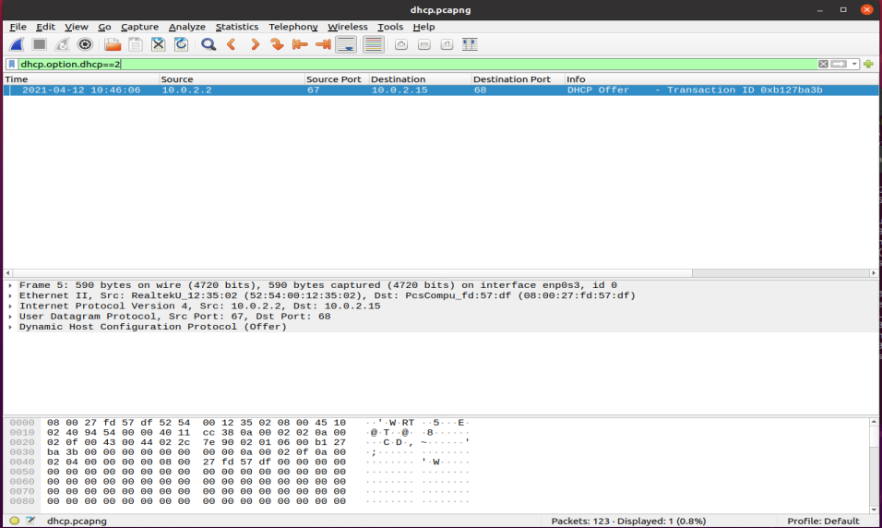

The filter is **dhcp.option.dhcp==2**

Here 2 for offer.

Here Offer =Reply

**ACK messages (2 marks) in that round.**

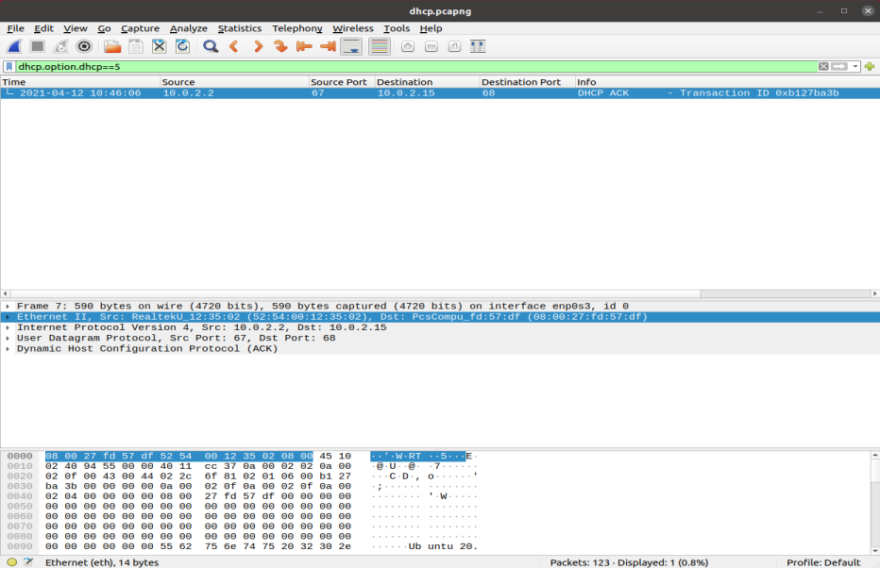

The filter is **dhcp.option.dhcp==5** where 5 is for acknowledgement.

**Find out IP addresses of the DHCP server (2 marks) and client (2 marks). Write the filter and show the output in a screenshot.**

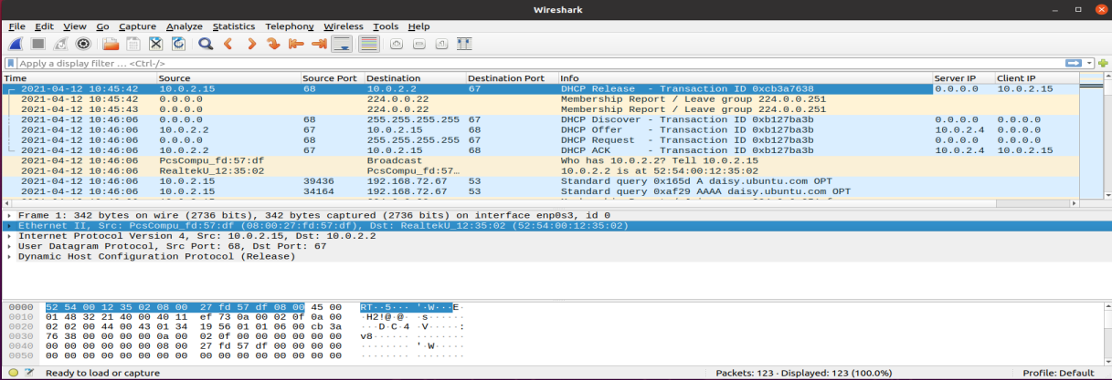

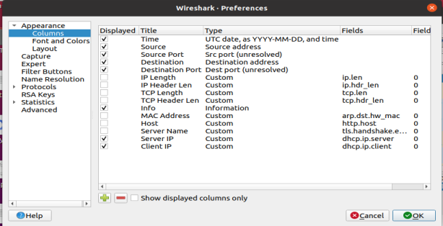

Filter for IP address of server: **dhcp.ip.server**

Filter for IP address of client: **dhcp.ip.client**

**2. Show a round of execution of the ARP protocol.**

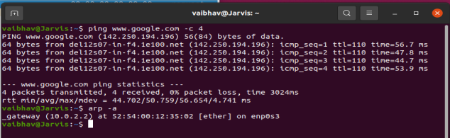

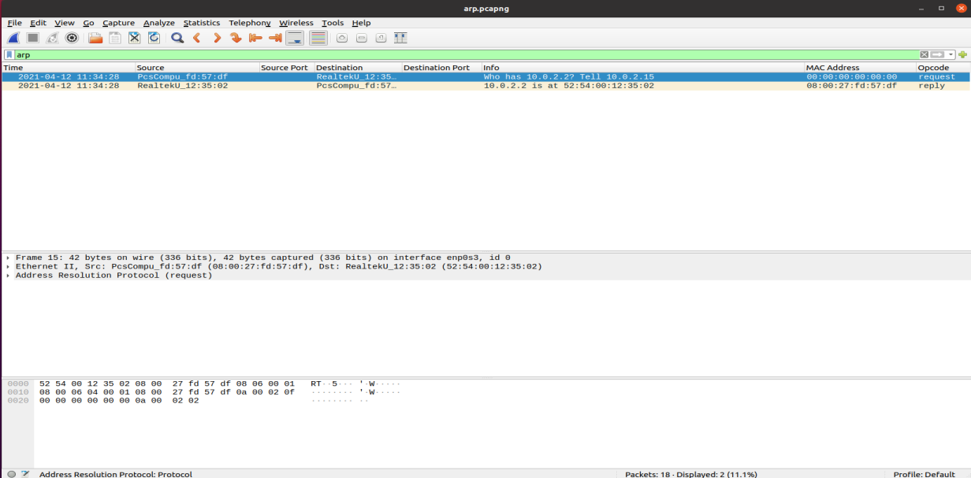

The filter used here is **arp** to filter It out.

**Show ARP Request (2 marks)**

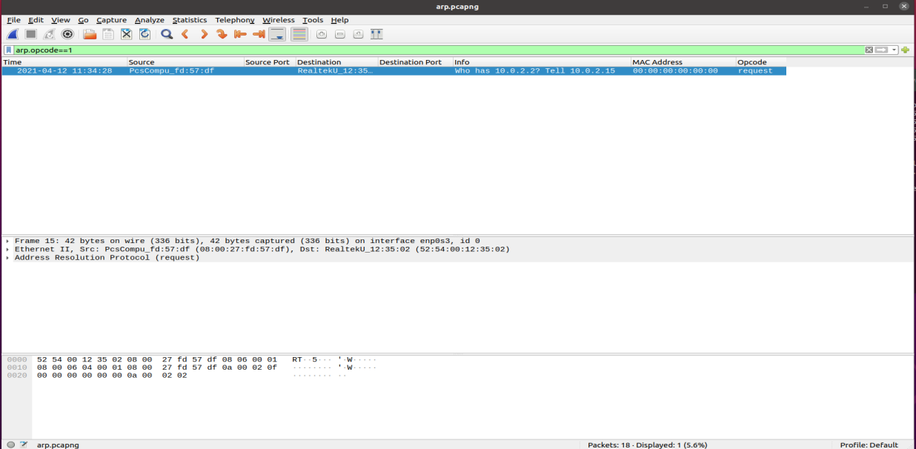

The filter is **arp.opcode==1** for request

**Reply (2 marks) messages in that round.**

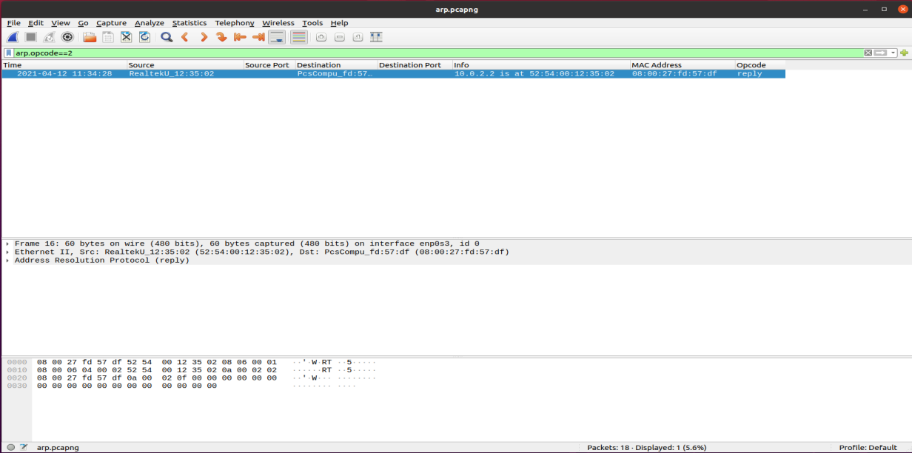

The filter is **arp.opcode==2** for reply

**Find the MAC address of the replier (2 marks). Write the filter and show the output in a screenshot.**

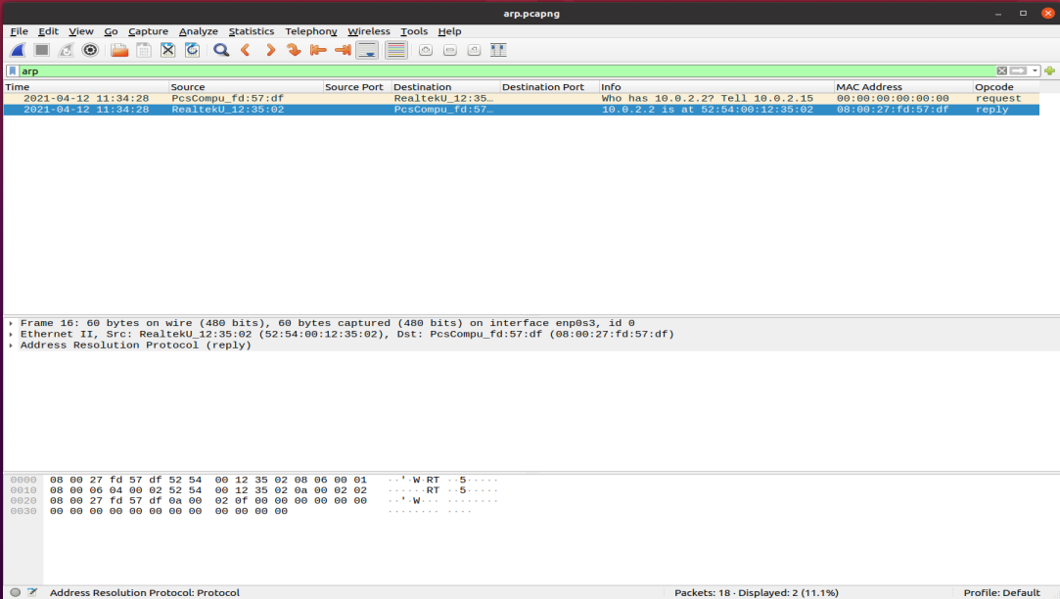

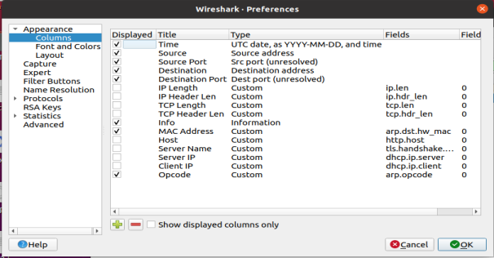

The filter for the MAC address is **arp.dst.hw_mac.** I have added a column to get the MAC Addresses.

**3. Find the MAC address and the IP address of the Gateway router (2 marks). Write the filter and show the output in a screenshot.**

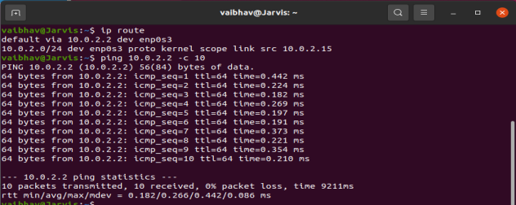

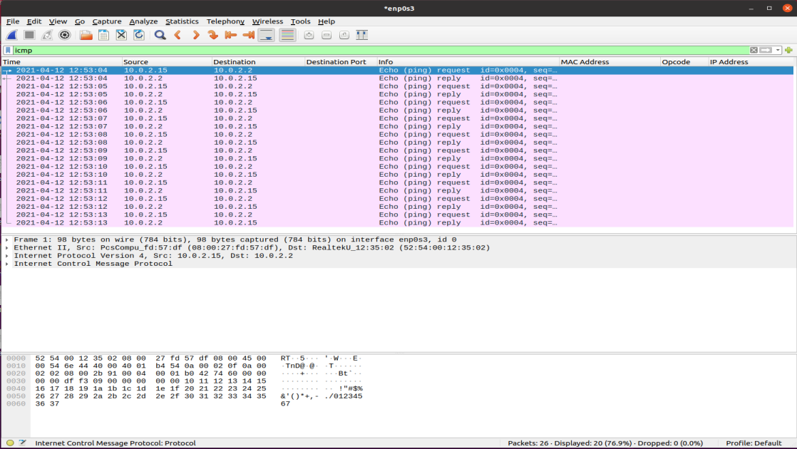

The filter is **icmp.**

The IP Address of the Gateway Router is 10.0.2.2 as seen from the image above.

The MAC Address of the Gateway Router is 52:54:00:12:35:02